Margin on the top: 20mm

TITLE of the abstract should be in upper case. the font is times new roman 11pt in bold capital letters

Takahiro Wada¹, Akira Yamada², Given Family³

¹Ryukoku University, Japan, ²Tokyo Institute of Technology, Japan, ³Institution, Country

This is a sample of the abstract which should be submitted for LSOE-2019 and this file can be used as template.
All abstracts must be written in English and should be submitted in camera-ready format. The abstract should be no more than six pages on A4 size (210 mm x 297 mm) paper. The paper margin should be 20 mm at the top and bottom, and 25 mm on the both sides.
Regarding fonts, only Times New Roman and Symbol can be used. Please make sure not to use other local fonts. The title of the abstract should be written in UPPERCASE, bold, 11pt and centered. Author's name should be written in 11 pt in bold type and affiliation and corresponding e-mail in 10.5pt, centered. If there are several authors or affiliations, related numbers should be given using superscripts. Abstract text should be written in 10.5 pt, justified. Use only SI units. Formulas and special characters can be used, but special care should be taken that these do not change the line spacing (i.e. single spacing) and can be properly converted to a PDF version.
Please note that the abstract can include figures and tables as long as they fit in 6 pages. Figures and tables should be referred in the text to "Figure 1" or "Table 1," with the proper numbering. All figures should contain proper labeling, showing clear images in the original size in black and white. All figures and tables should be directly inserted into the file and be accompanied by a caption, starting with "Figure 1: " as the example shown below. Care should be taken that the final abstract file is no larger than 10MB (strict limit in the on-line submission procedure).
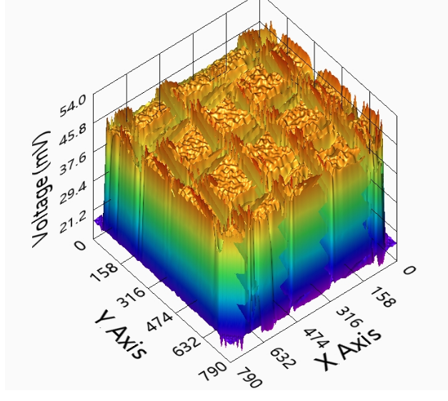

Margin
on the left: 25mm
Margin
on the right: 25mm

Figure 1: Sample of figures in the abstract

Margin at the bottom: 20mm
Margin at the bottom: 20mm

